**QUESTION 1**

1. To keep track of students and their advisors, a university uses the table structure shown below. Assuming that the sample data are representative, draw a dependency diagram in Visio that shows all functional dependencies including both partial and transitive dependencies. (*Hint:* Look at the sample values to determine the nature of the relationships.)

|  |  |  |  |  |
| --- | --- | --- | --- | --- |
| **Attribute Name** | **Sample Value** | **Sample Value** | **Sample Value** | **Sample Value** |
| **STUDENT_ID** | 123456 | 478596 | 123456 | 389987 |
| **STUDENT_NAME** | Kim Brutt | Mary King | Kim Brutt | Donald Nouglle |
| **ADVISOR_ID** | 123 | 473 | 567 | 123 |
| **ADVISOR_NAME** | John Smith | Kim Young | Julia Roberts | John Smith |
| **DEPARTMENT_CODE** | AIT | CS | ECE | AIT |
| **DEPARTMENT_NAME** | Applied Information Technology | Computer Science | Electrical Engineering | Applied Information Technology |
| **APPOINTMENT_DATE** | 01/01/2009 | 05/03/2009 | 03/06/2009 | 01/01/2009 |

2. Using the initial dependency diagram drawn in question 1, remove all partial dependencies, draw the new dependency diagrams in Visio, and identify the normal forms for each table structure you created.

3. Using the table structures you created in question 2, remove all transitive dependencies, and draw the new dependency diagrams in Visio. Also identify the normal forms for each table structure you created. If necessary, add or modify attributes to create appropriate determinants or to adhere to the naming conventions.

4. Using the results of question 3, draw the fully labeled Crow's Foot ERD in Visio. The diagram must include all entities, attributes, and relationships. Primary keys and foreign keys must be clearly identified on the diagram.

**Solution:**

Let’s re-arrange the table

|  |  |  |  |  |  |  |
| --- | --- | --- | --- | --- | --- | --- |
| **ADVISOR_ID** | **ADVISOR_NAME** | **DEPARTMENT_CODE** | **DEPARTMENT_NAME** | **APPOINTMENT_DATE** | **STUDENT_ID** | **STUDENT_NAME** |
| 123 | John Smith | AIT | Applied Information Technology | 1/1/2009 | 123456 | Kim Brutt |
| 473 | Kim Young | CS | Computer Science | 5/3/2009 | 478596 | Mary King |
| 567 | Julia Roberts | ECE | Electrical Engineering | 3/6/2009 | 123456 | Kim Brutt |
| 123 | John Smith | AIT | Applied Information Technology | 1/1/2009 | 389987 | Donald Nouglle |

**Primary key:**

{ADVISOR_ID, STUDENT_ID}

Cause: I choose the determinant key of the repeating group and assign those as primary keys.

**Partial Dependency:**

ADVISOR_ID -> ADVISOR NAME, DEPARTMENT_CODE, DEPARTMENT_NAME, APPOINTMENT_DATE

STUDENT_ID -> STUDENT_NAME

**Transitive Dependency:**

DEPARTMENT_CODE -> DEPARTMENT_NAME

**1NF:**

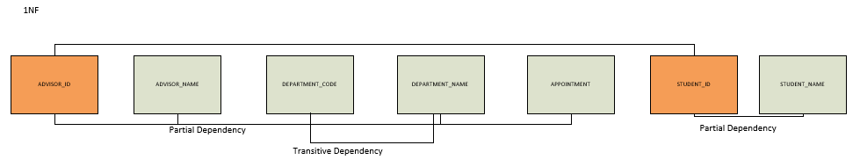

**2NF:**

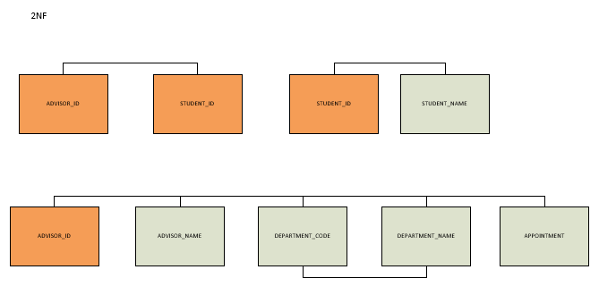

**3NF:**

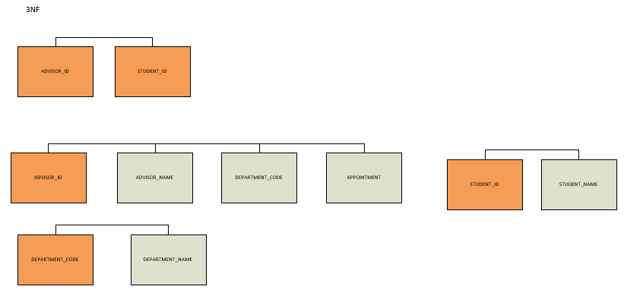

**DIAGRAM:**

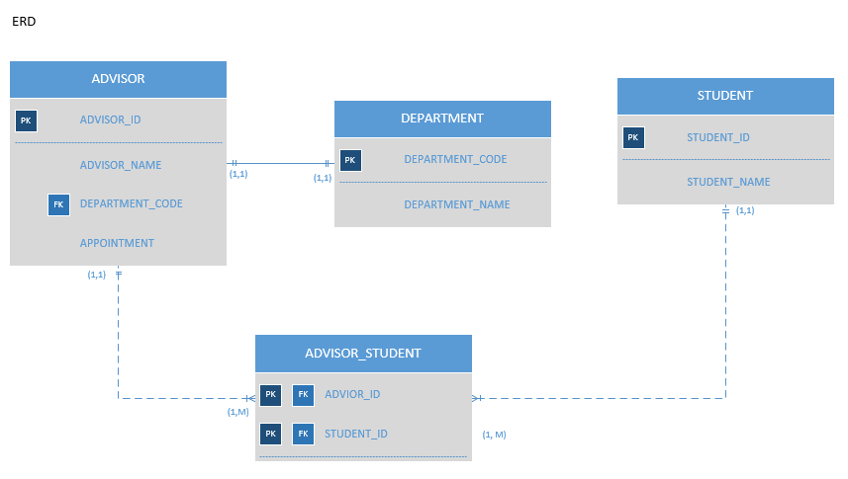

**PS:**  I put the relationship (1:1) between ADVISOR and DEPARTMENT based on the question. In the question there is no evidence that one department can have many advisors. Moreover, there is no clear business rules also stated.